Invoices

This document will show you how to add a new Invoice to jBilling. You may know that invoices are in fact reports done with Jasper Reports. Remember that you can use iReports as a User Interface to make all the changes you may need. Additional information on this topic will not be covered in this tutorial. This document assumes that you already have your *jrxml* file with your **NEW** invoice design.

In order to tell jBilling that there is a new invoice you need to follow these steps:

1. Place the invoice file in a specific folder
2. Run a grails command to compile the *jrxml* file and get a jasper one
3. Configure jBilling using the GUI to use your custom design

# Place the invoice file in the correct folder

Once you have your *jrxml* file you need to put it in the following path (in our example it’s going to be called *tutorial\_invoice.jrxml)*:

*{jbilling\_folder}/descriptors/designs/*

*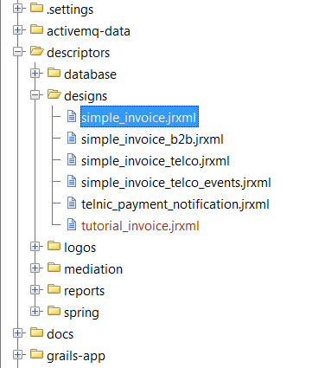*

# Run grails command to compile the invoice file

Once the file is in place you need to run a grails command to compile the file. This command will use the jasper report library to compile the *jrxml* file. The result will be a *jasper* file that is going to be used by the application.

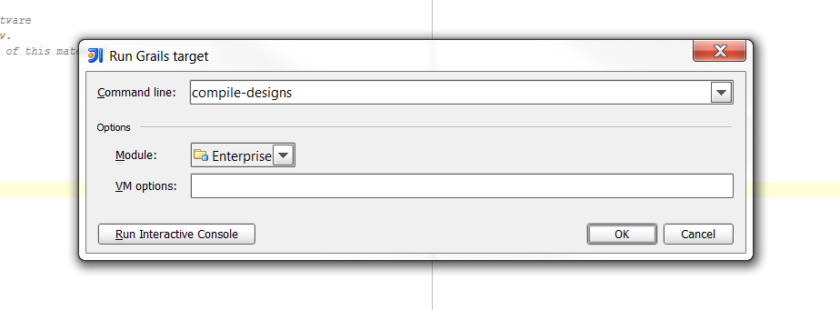

This will copy the compiled file to the */resources/designs/* folder.

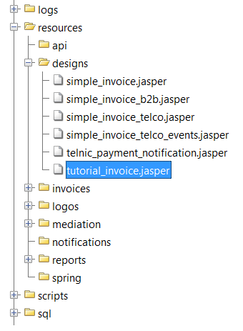

# Configure jBilling

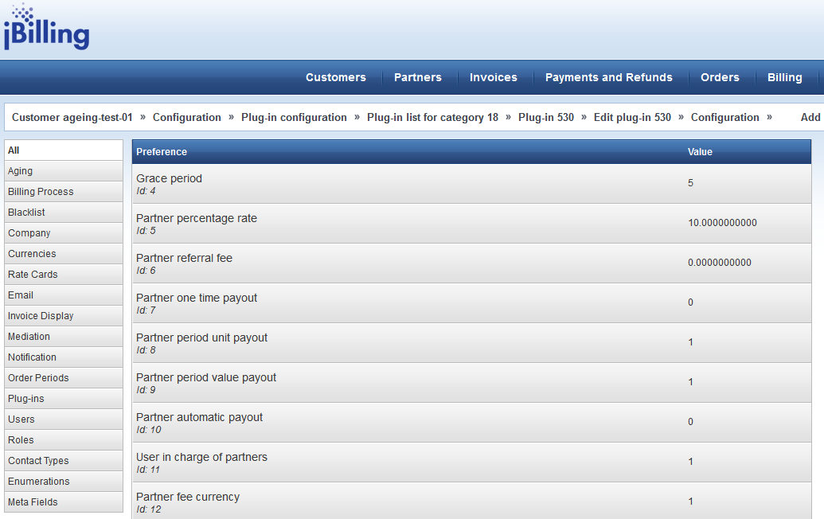C:\Users\jmvidal\Desktop\menu.pngAt this point, the file is in its correct place and it has been compiled. The only thing left to do is configure the application to use your new invoice design. To do this, go to the Configuration menu.

Click on the Plug-ins option available in the menu on the left:

From the plugins list select **Notifications**

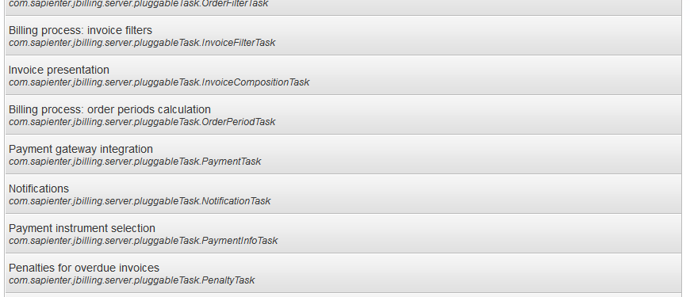

The list of Plug-ins under the Notifications category will be shown.

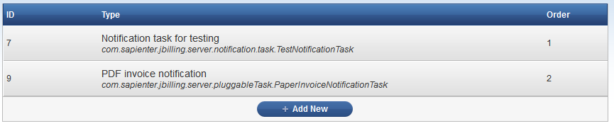

Select the *PDF invoice notification* Plug-in.

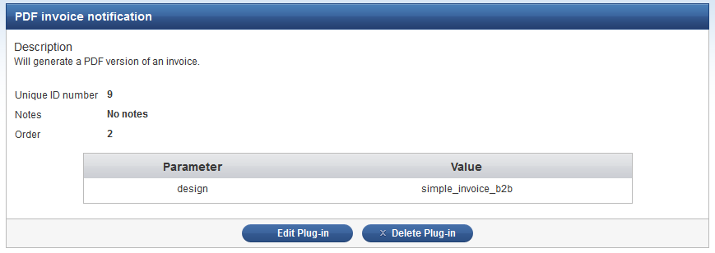

Click on the Edit Plug-in button to edit the configuration.

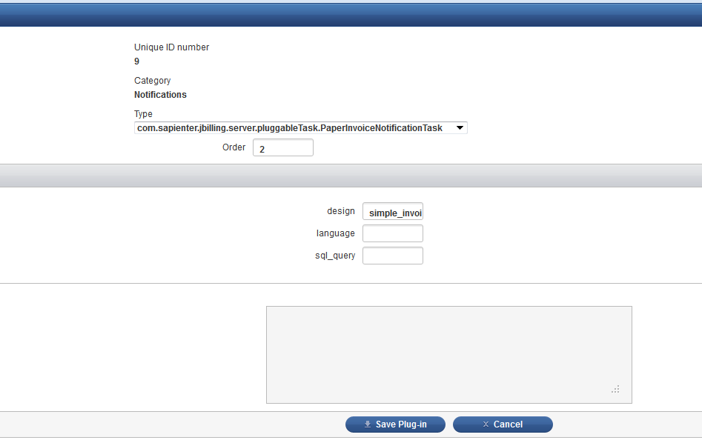

In the Plug-in configuration screen you need to ensure that the parameters have the following data:

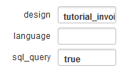

* In the *design* parameter you have to put the name of the invoice file without the extension.
* In the *language* parameter you can put *true* or *false* to indicate whether or not you have internationalized invoices. This means that the system is going to search for an invoice file with the language code at the end of the name.
* In the *sql\_query* parameter you set it to *true* if you are planning on getting the data for the invoice using sql queries. Otherwise, set it to false if all the information is going to be passed from the application.

In our example, the *design* field will have *tutorial\_invoice.* Enter *true* to the *sql\_query* field. After that’s done, click on the *Save Plug-in* button.

# Test the new invoice

C:\Users\jmvidal\Desktop\menu_invoices.pngNow that you have completed every step, you will want to test your invoice and also see how the new invoice design looks in the user interface. To do this you need to click on the Invoices section in jBilling’s menu.

Select an invoice from the list.

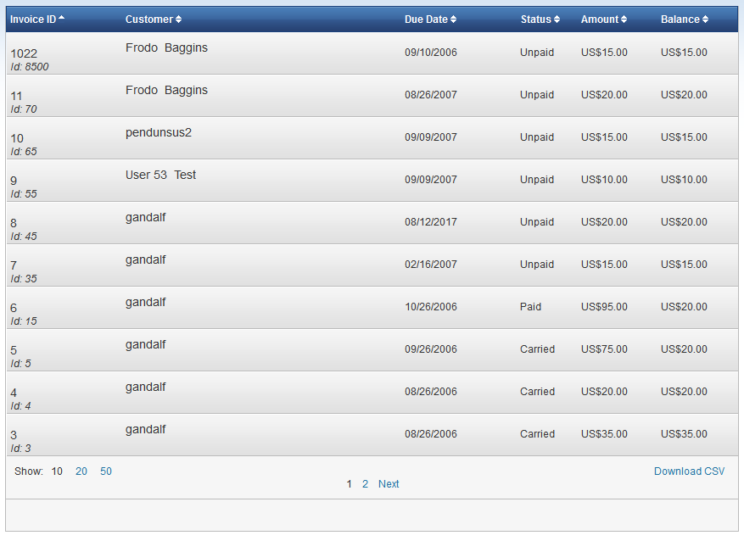

The invoice information will appear on the right hand side. Scroll down to the bottom of the page until you see the Download PDF button. Click on it.

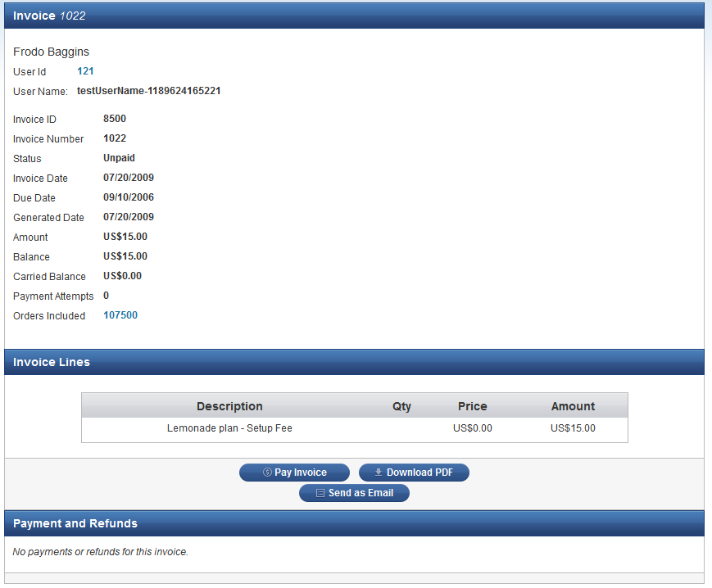

Depending on which browser you are using, you will receive a download popup window or the invoice PDF in a new tab. The following is an example of the previous invoice and the new one so that you can see that the changes were taken into account.

Old Invoice

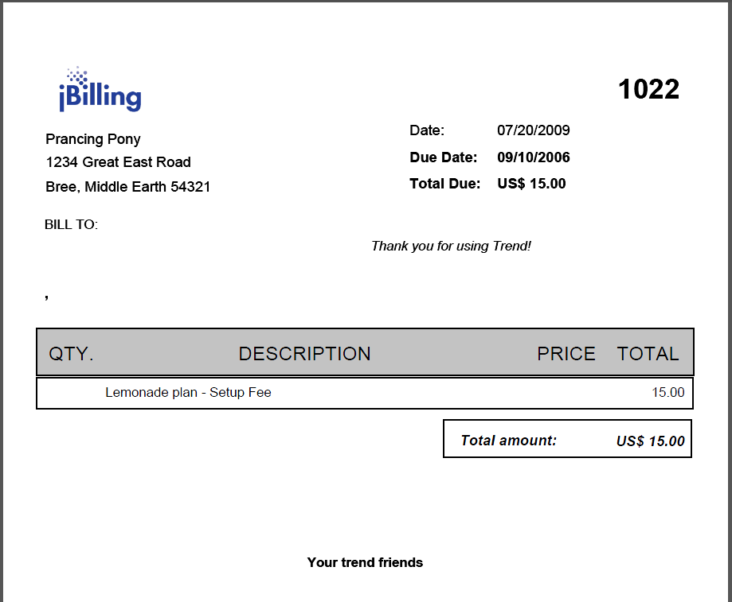

New Invoice

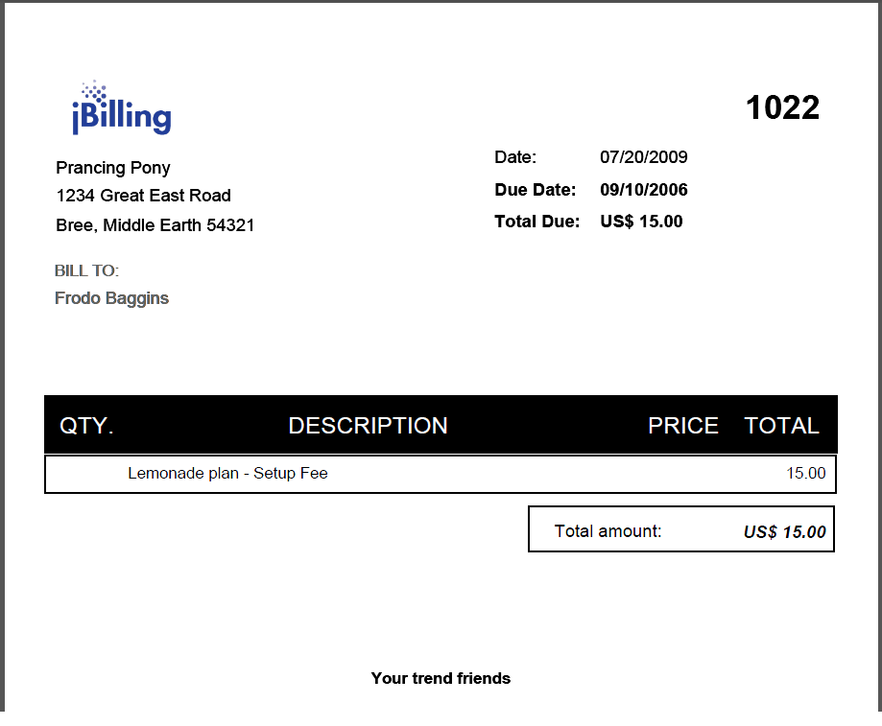

Summary

Here is a summary of all the files that were modified/created in order to complete this exercise.

|  |  |  |
| --- | --- | --- |
| File | Updated or Created? | Description |
| *descriptors/designs/tutorial\_invoice.jrxml* | Created | Jasper Report invoice design file. |